**Chemistry Study on Hot Corino Serpen South CARMA-7**

Haotian Liu (under supervision of Dr. Adele Plunkett)1

1 University of Virginia

E-mail: hl7gr@virginia.edu

11/29/2019

Abstract

This thesis reports molecule line identification results on a recently discovered hot corino source, CARMA-7 in Serpen South region from its ALMA observation data. Complex organic molecules such as (CH3)2CO (Acetone), CH3OH (Methanol) and H2NCH2CN (Aminoacetonitrile) are detected. By analyzing contour plots of the source, it can be (tentatively) concluded that CARMA-7 is not only rich in chemistry but also undergoing rapid motions including bipolar outflow jets and a possible rotating accretion disk.

Keywords: hot corino, astrochemistry, ALMA

**1. Introduction**

This thesis studies the chemistry of a recently discovered hot corino-like protostar, CARMA-7 in the Serpen South region. CARMA-7 is one of the very few hot corinoes discovered so far and has a high degree of chemical richness and motion traces of possible bipolar molecular outflow jets. This thesis report will attempt to list, plot and discuss molecular line identification results and motion signatures of CARMA-7 from a set of 6 spectral windows of ALMA observation data in 2015.

**2. Observation**

The ALMA observation on CARMA-7 is divided into 6 spectral windows, each with a different rest frequency (GHz) and frequency range but same VLSR of 8.0 km/s. The observation data cubes are divided into multiple channels: spectral window 0, 1, 2, 4 and 5 have 960 channels whereas spectral window 3 has 1920 channels. All raw data cubes have a 360 × 360 dimension, resulting in a total of 129600 pixels per slice.

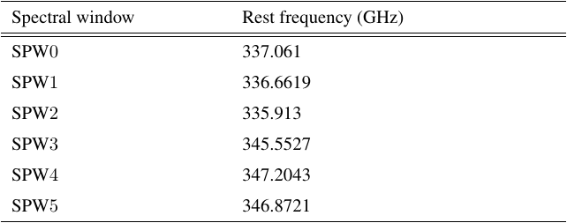

Figure 1 All 6 spectral windows and their rest frequencies

**3. Methods**

To accurately identify all molecules from all 6 spectral windows, a variety of continuum substraction and line identification tools were attempted. These tools include STATCONT, ADMIT (ALMA Data Mining Toolkit, integrated with CASA) and XCLASS. Raw fits data cubes were first cropped (to eliminate impacts of the cube’s original circular shape on calculation of background noise rms and improve focus on center area) and continummed substrated (with noise level set to 1) with STATCONT to produce line cubes that were ready as input file for ADMIT’s ContinuumSub and LineIdentification tasks.

To understand the physical structure and motions of CARMA-7, contour plots based on background rms (10 levels from 2× background rms to 20× background noise rms) were drawn for channels that shows traces of explicit strcuture / identifiable motions in each spectral window. Background noise were calculated from pixel blocks of a specified size from all four corners (upper left, lower left, upper right, lower right) for each channel plotted.

**4. Results**

**Detected lines and their distribution**

Figure x to figure x shows some “promising” molecule lines (with an identifiable line height and overall profile) from spectral window 0 to 5. In these observations, CARMA-7 was found to be chemically rich, with some spectral windows dominated by one molecule (spectral window x, x and x) with high intensity peak / rms ratio and broad lines with sometimes complex shapes. The most noteworthy detections are (CH3)2CO (Acetone), CH3OH (Methanol) and (CH2OH)2 (Ethylene glycol), which are found in 5 out of all 6 spectral windows. In addition, some more complicated organic compounds with higher molar mass such as CH3CHO (Acetaldehyde), H2NCH2CN (Aminoacetonitrile), CH3CH2OH (Ethanol) and CH3OCHO (Methyl formate) are also deteced with multiple occurrence in at least 4 out of 6 spectral windows. Interestingly, the complexity / molar mass of molecules detected does not seem to have a correlation with their commonness across all 6 spectral windows. Nevertheless, the exact spatial distribution of each molecule are still subjected to future study.

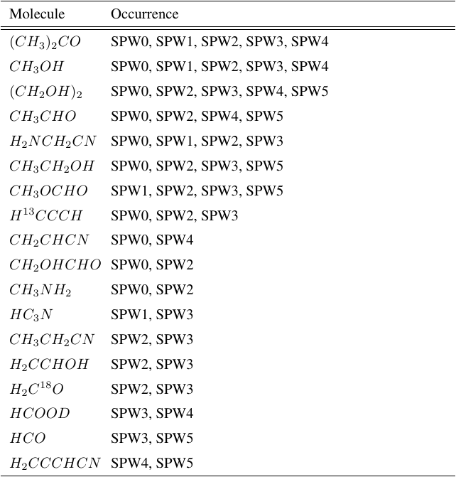

Figure 2 Selected identified lines that occur in multiple spectral windows

It was also found that CARMA-7 shares a notable amount of molecules with other discovered hot corino sources including B335, HH212, L483, Ser-emb1 and SVS13-A. It was found out that Monohydric alcohols such as CH3CHO (Acetaldehyde), CH3OH (Methanol), some carbon nitriles such as CH3NH2 and silicon compound (SiO) are shared the most between CARMA-7 and other hot corino sources. In addition, CARMA-7 seems to have a higher richness of unique carbon nitriles and other nitrile compounds such as H2NCH2CN (Aminoacetonitrile) and CH3CH2CN (Propionitrile), all of which were identified in multiple spectral windows.

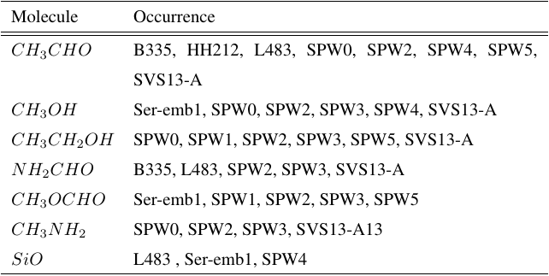

Figure 3 Selected lines that occurs in both CARMA-7 and other hot corino sources

However, it is also worth noting that these abovementioned common molecules are almost never the dominant lines with high peak intensity and width (or a well-defined line profile) in their spectral windows. For instance, spectral window 0, 1 has a dominant line of C17O and HCN respectively whereas spectral window 3, 4 has a dominant line of CO (absorption?) and SiO, none of which are shared with molecules detected in other hot corino sources. This may help pinpoint some unique molecules that are only observable from CARMA-7.

**Motion of the source**

In certain spectral windows such as spectral window 3 and spectral window 2, bipolar outflow jets are clearly visible and in progress with each channel but nevertheless are condensed only to a small channel range (figure x). In other spectral windows, the source does appear to be in some type of less well-defined motion that involves rotation around its (visual) center as in these spectral windows, the line-dense regions seem to be revolving around center of the plot. Such pattern is clearly visible in contour plots of spectral window 0 and spectral window 5, as shown in figure x and figure x.

It is notable that in all 3 spectral windows (2, 3 and 4) where bipolar outflow jets are observed, these jets are only visible for a rather small frequency range (all less than 20% of the spectral window’s frequency range).

Difficulties arise when trying to match molecular lines to channel ranges where signs of motions can be traced. Interestingly, the molecular line plot (peak vs. background rms) does not seem to correspond the slice plot well. This makes analysing source motion difficult since the molecular line shape, which typically reveals information about the source cannot be used to aid understanding of the exact motion. However, some prominent / dominant lines may still suggest relevant information on source motion, as they appear to be in particularly irregular shapes (example lines, figure x and x)

**5. Conclusion**

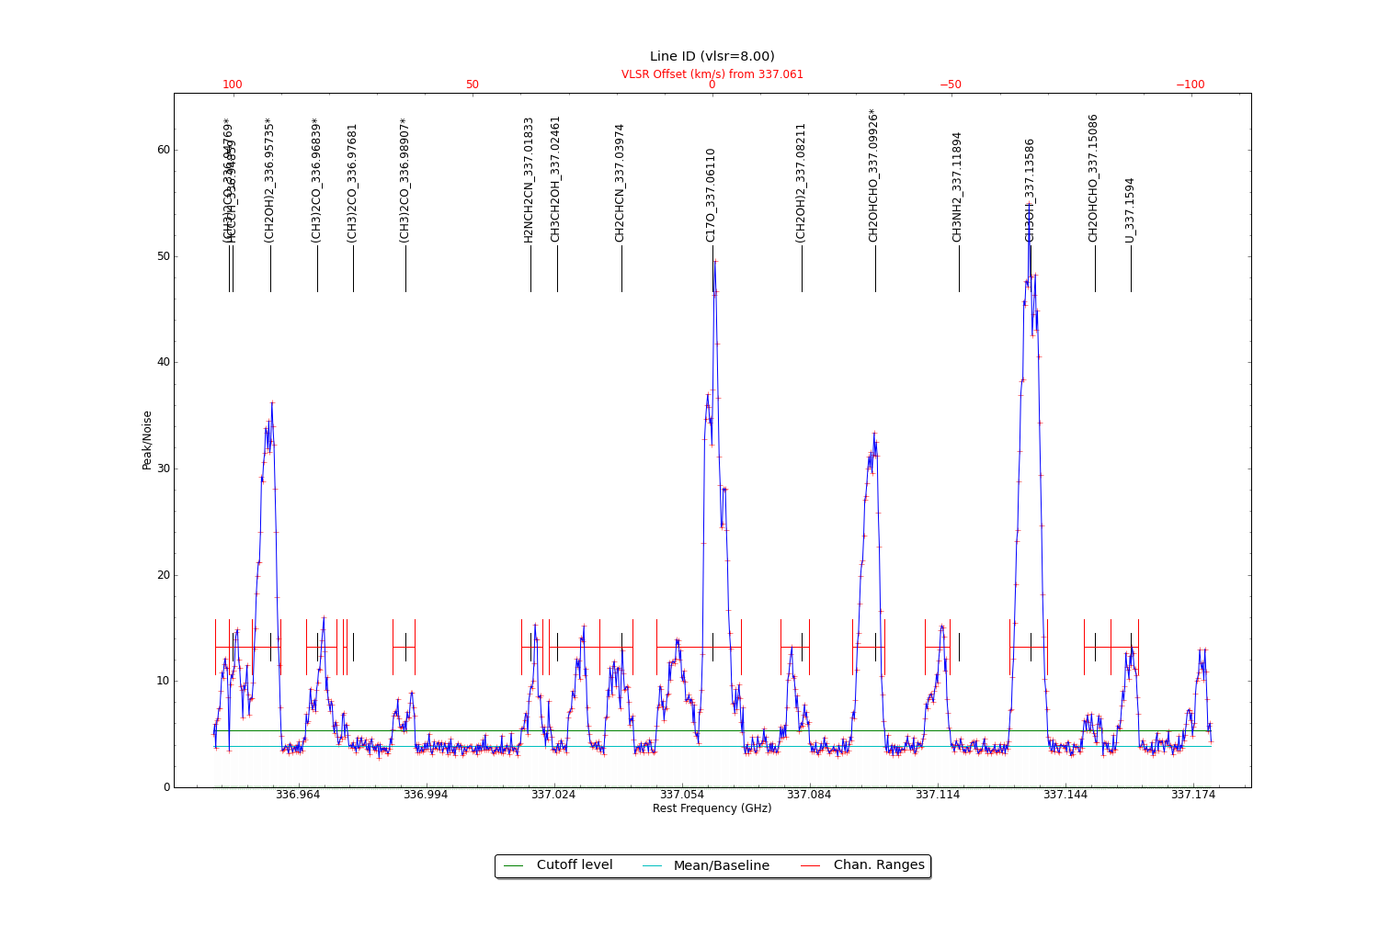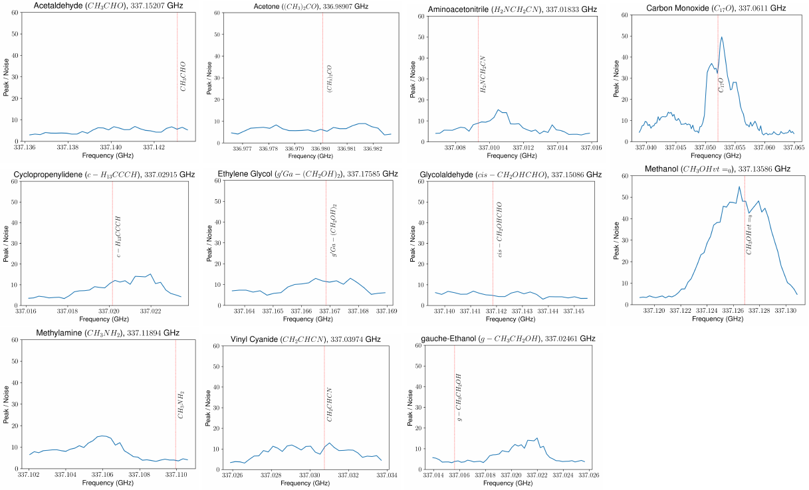**6. Appendix: plots and tables**

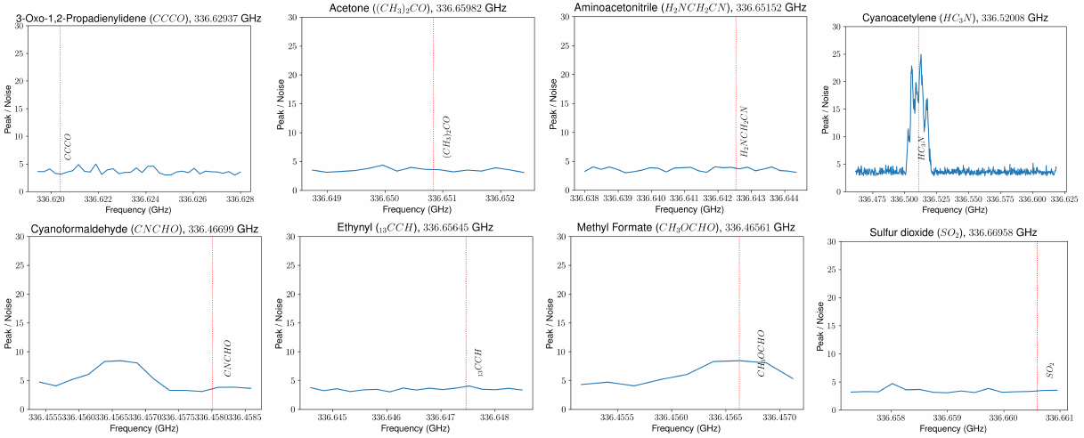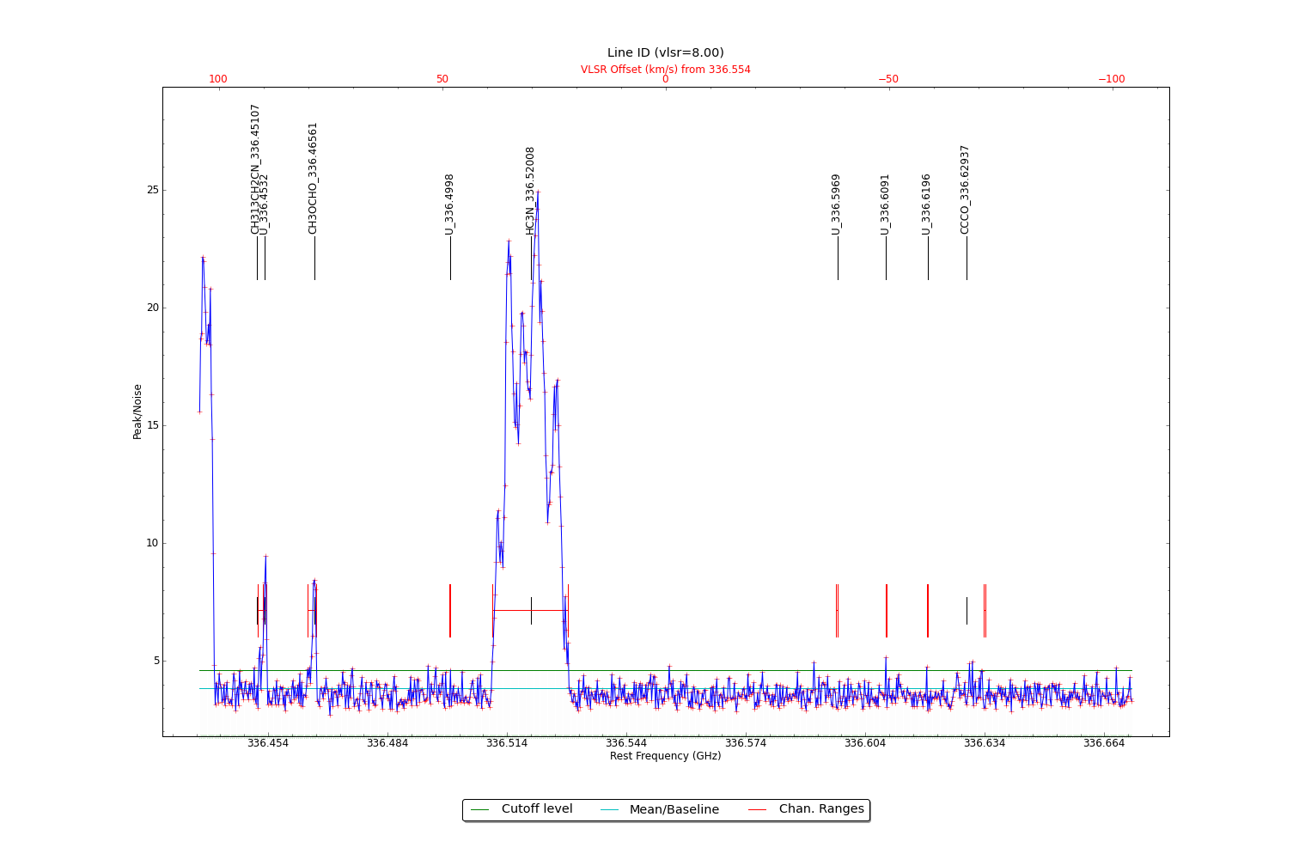

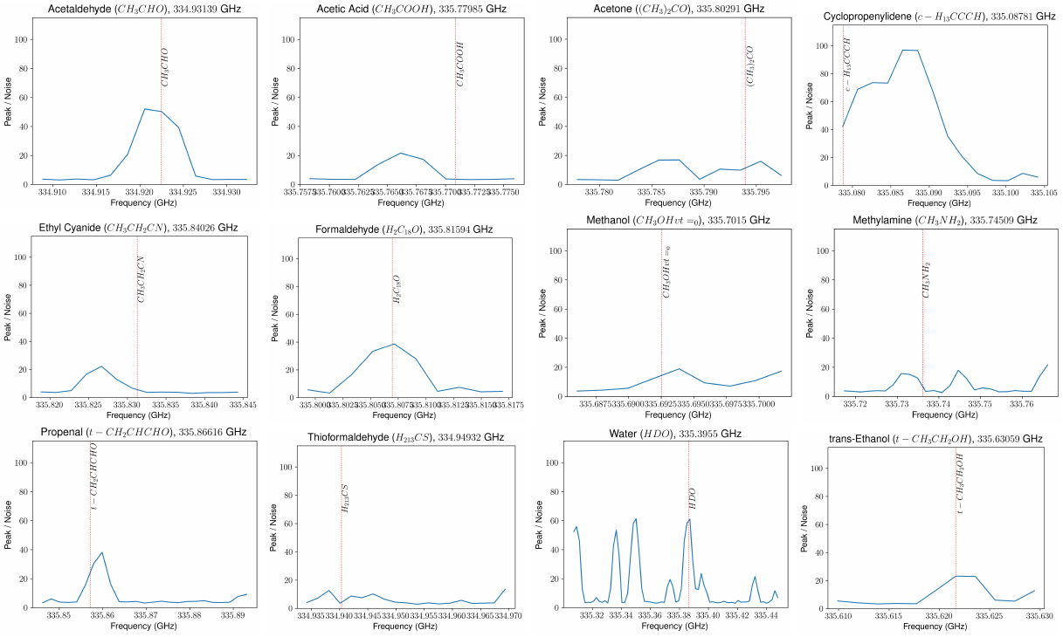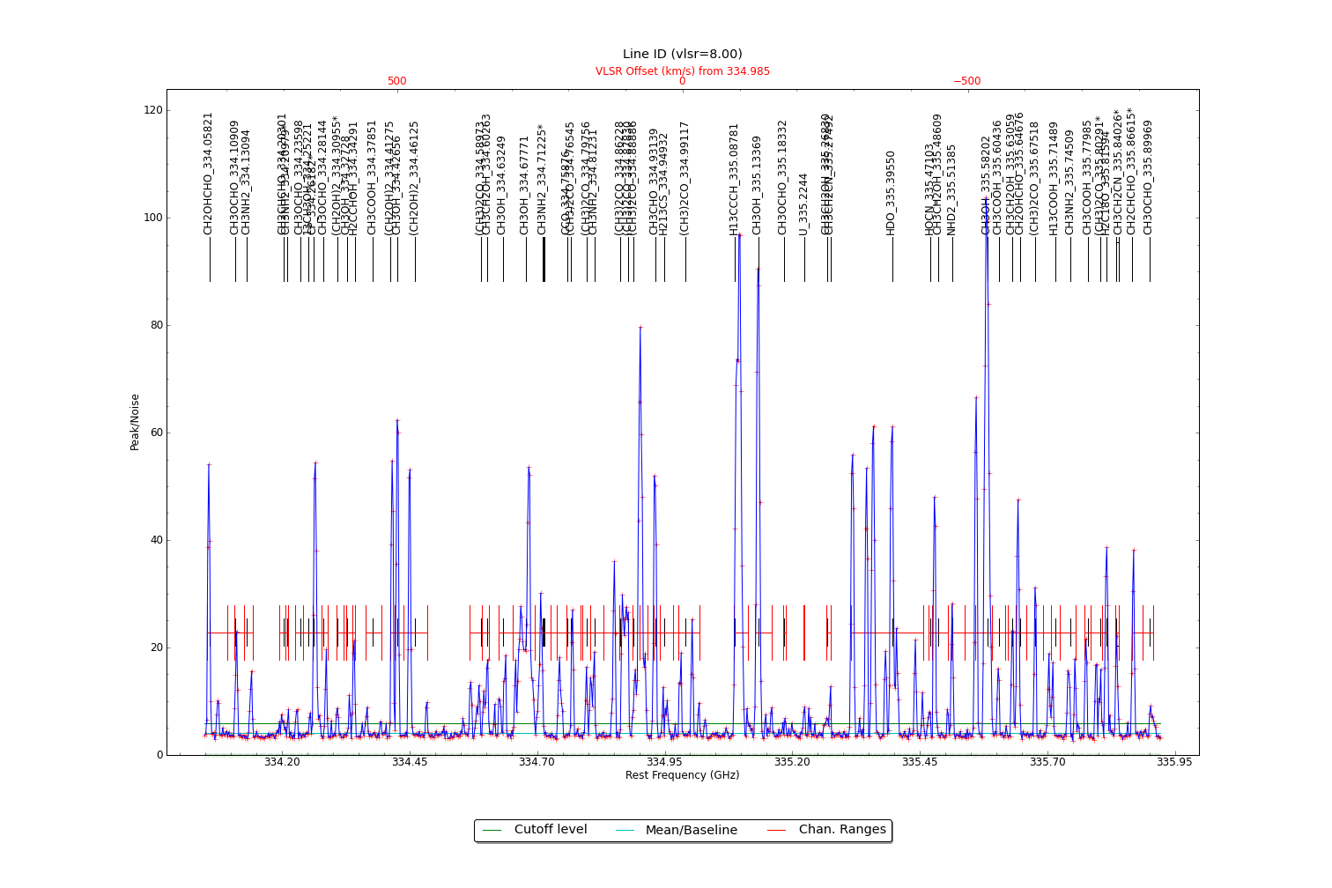

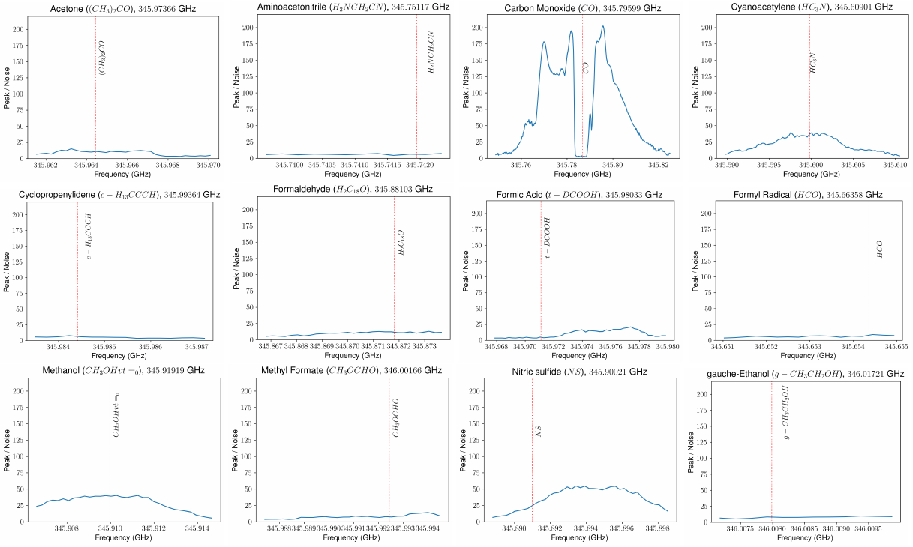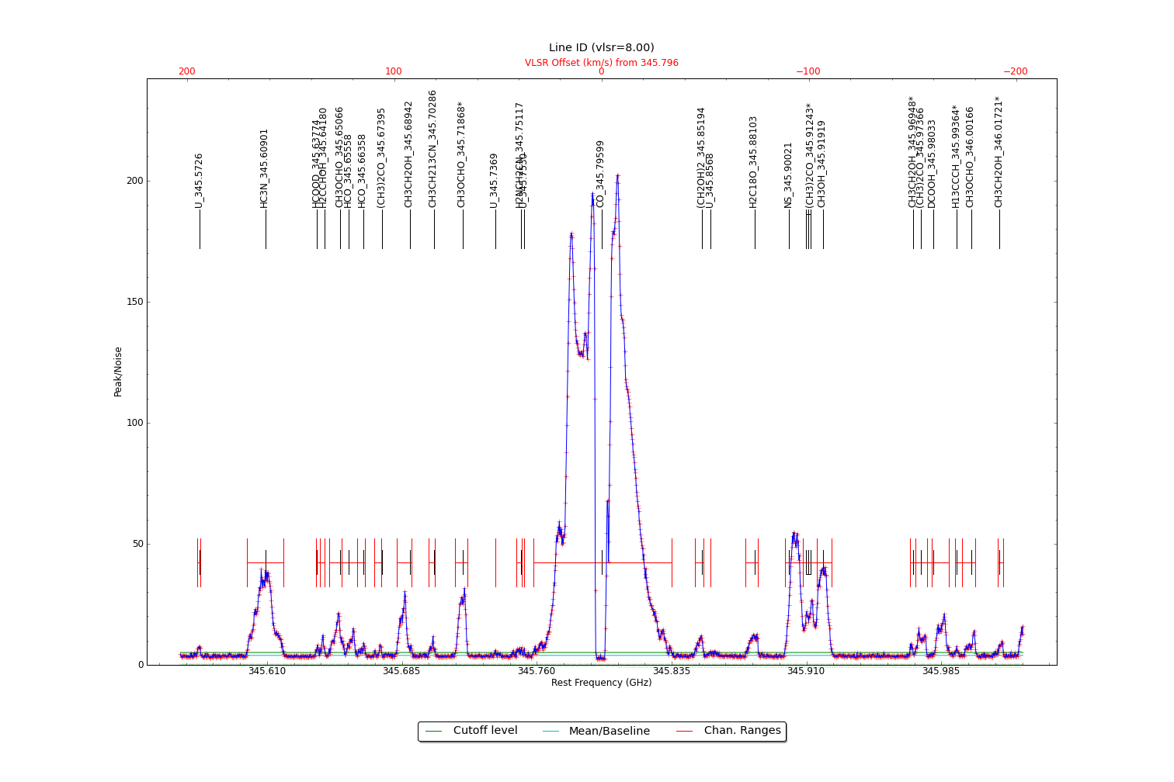

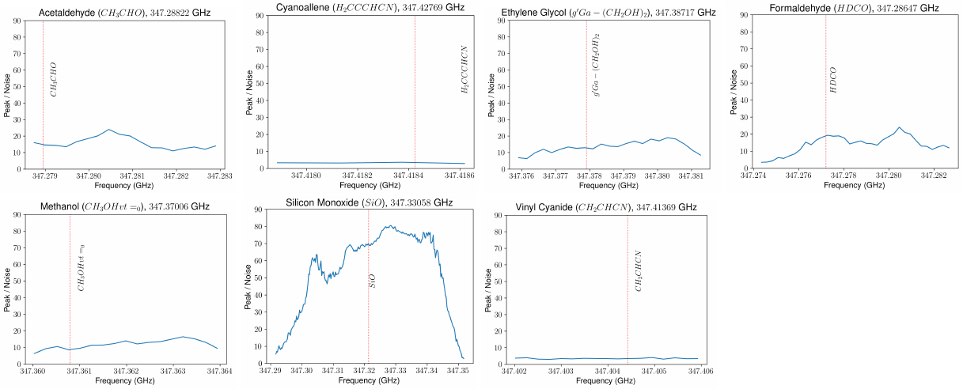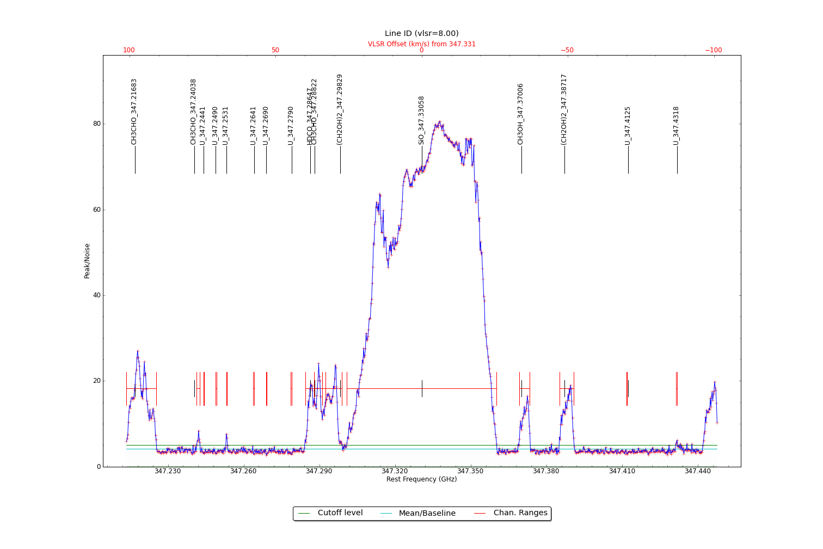

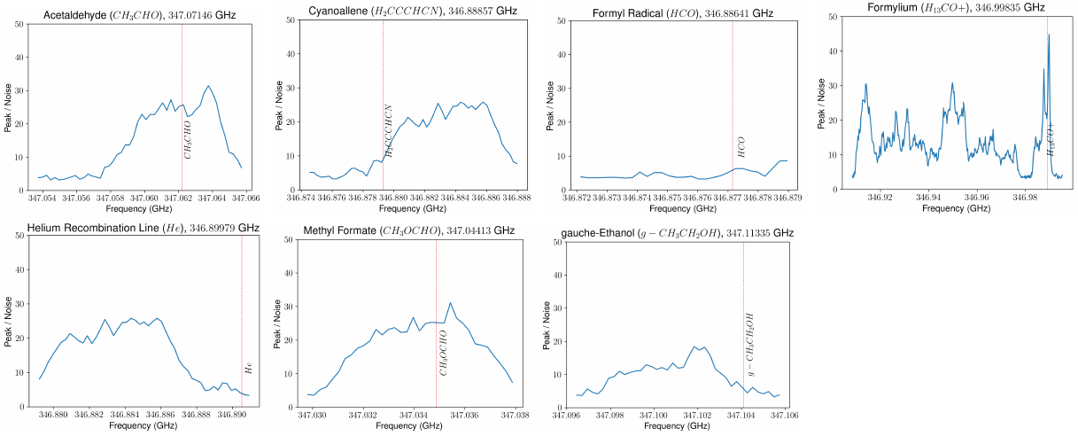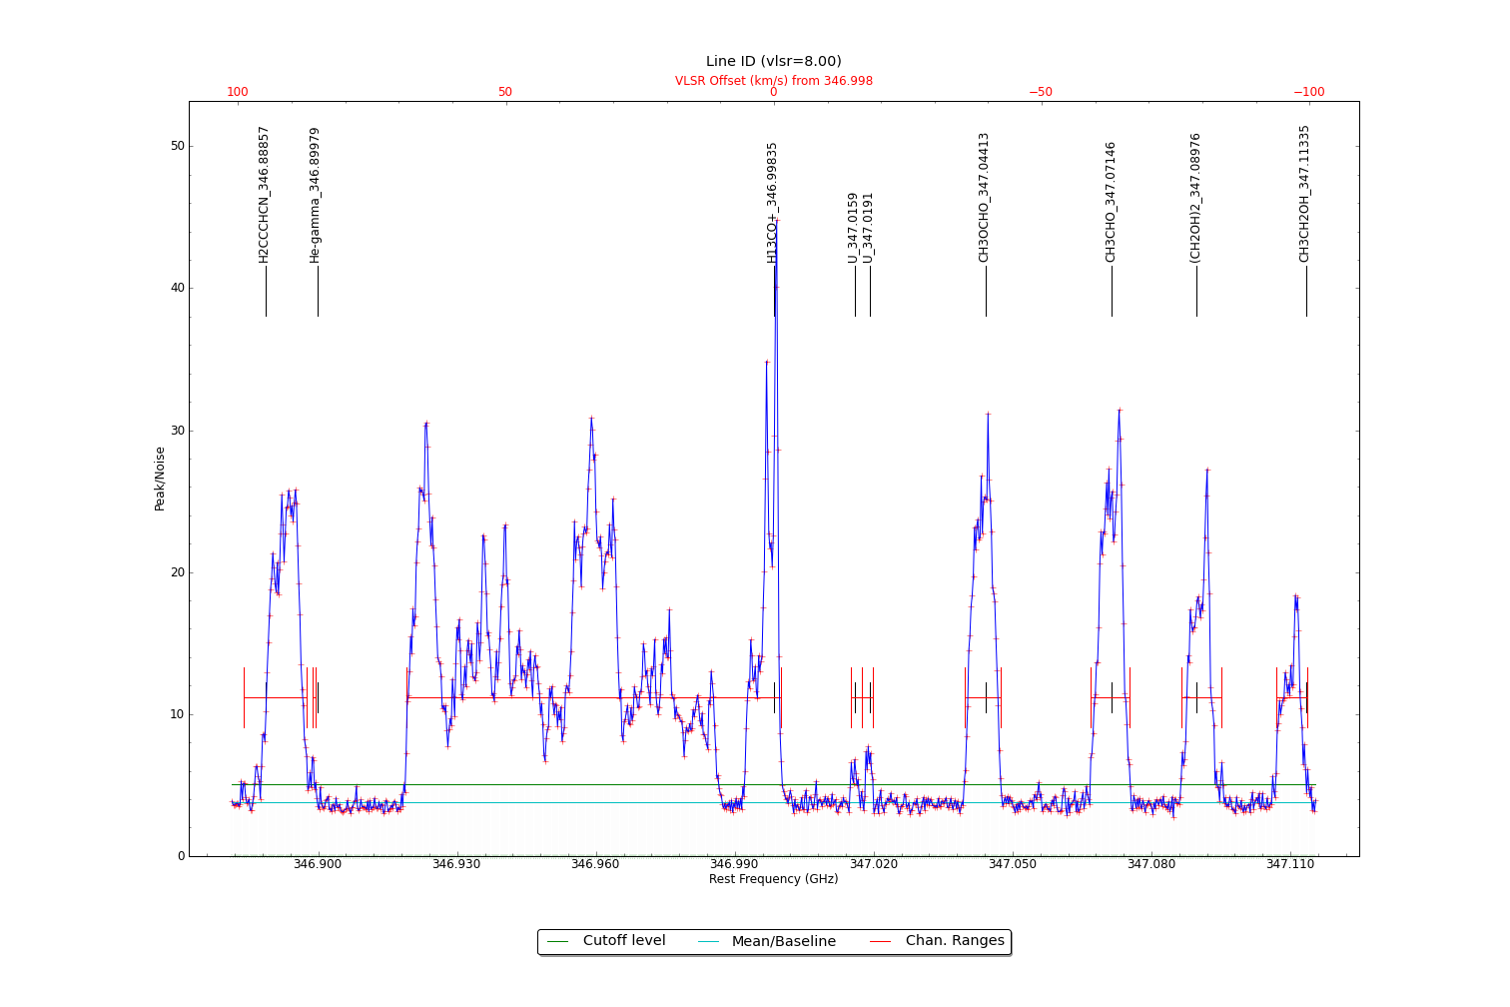

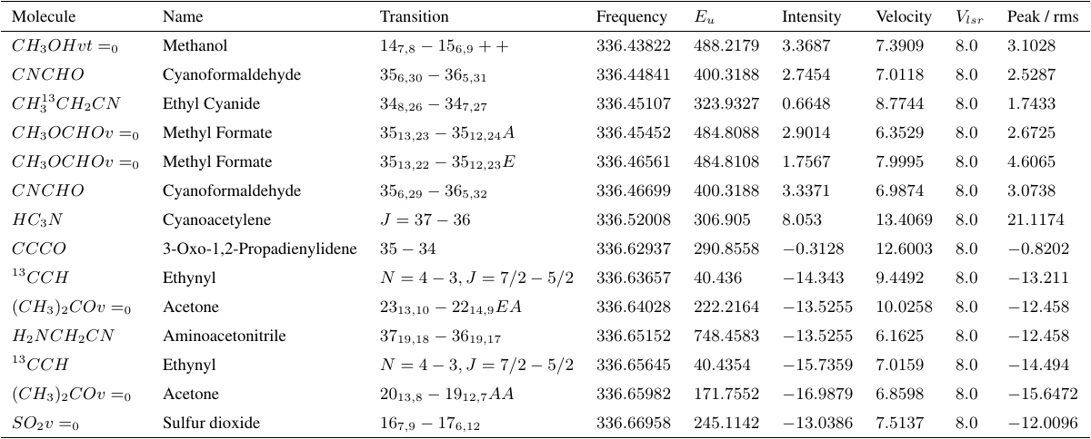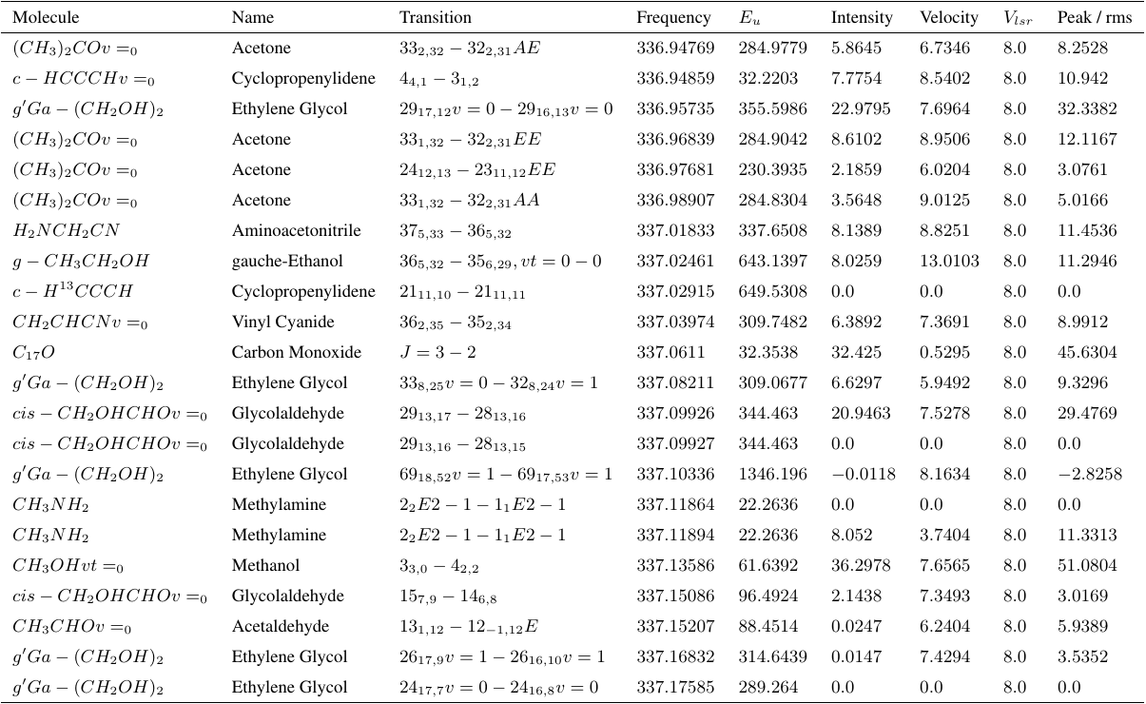

Figure 5 Identified lines in spectral window 1

Figure 4 Identified lines from spectral window 0

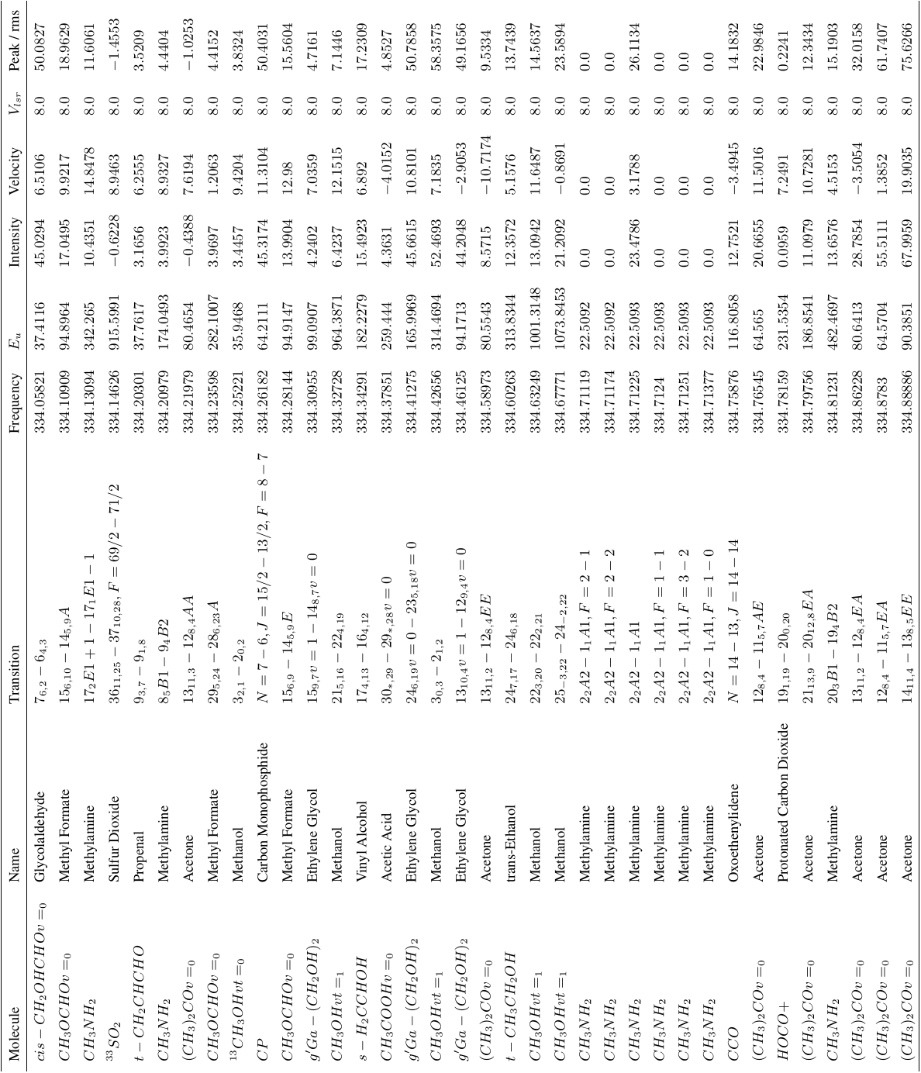

Figure 6 Identified lines in spectral window 2 (part i)

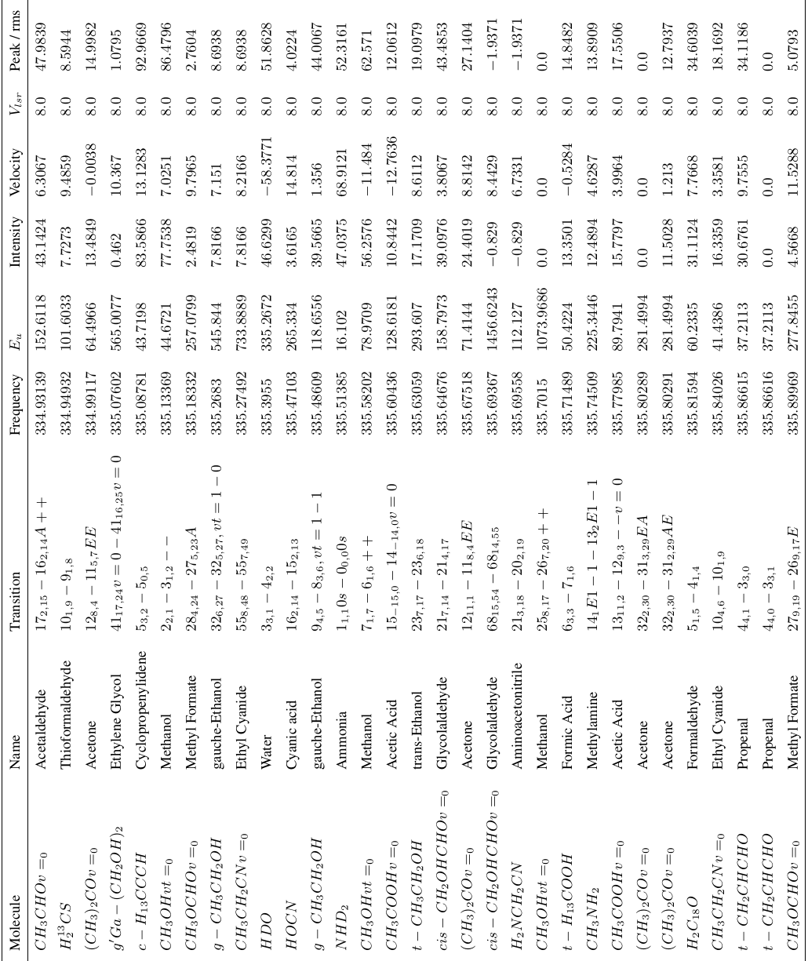

Figure 7 Identified lines in spectral window 2 (part ii)

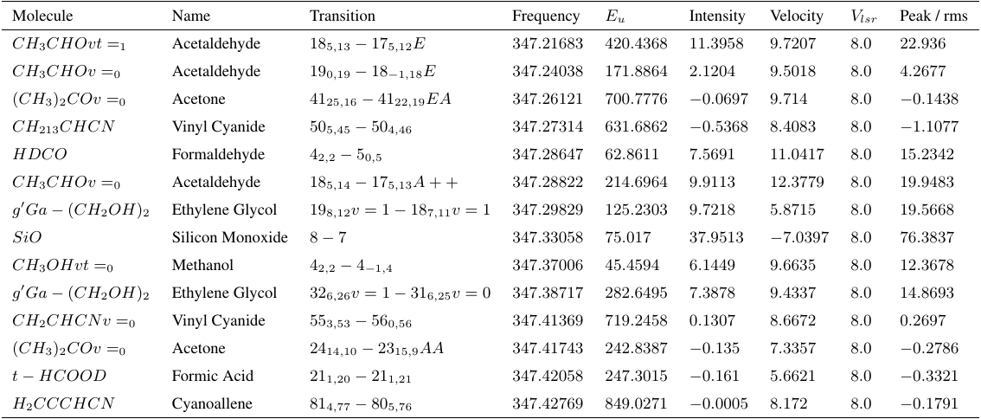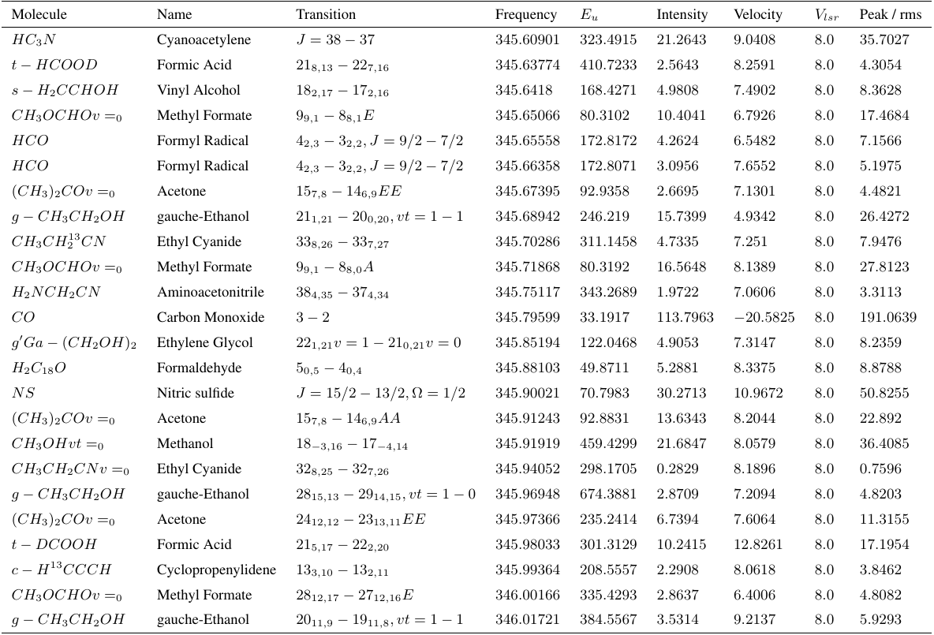

Figure 9 Identified lines in spectral window 4

Figure 8 Identified lines in spectral window 3

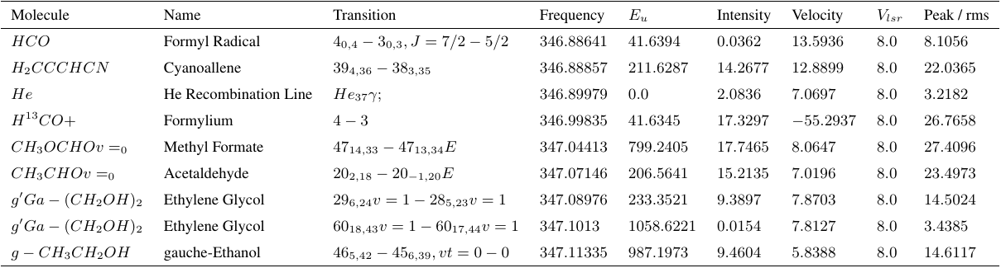

Figure 10 Identified lines in spectral window 5

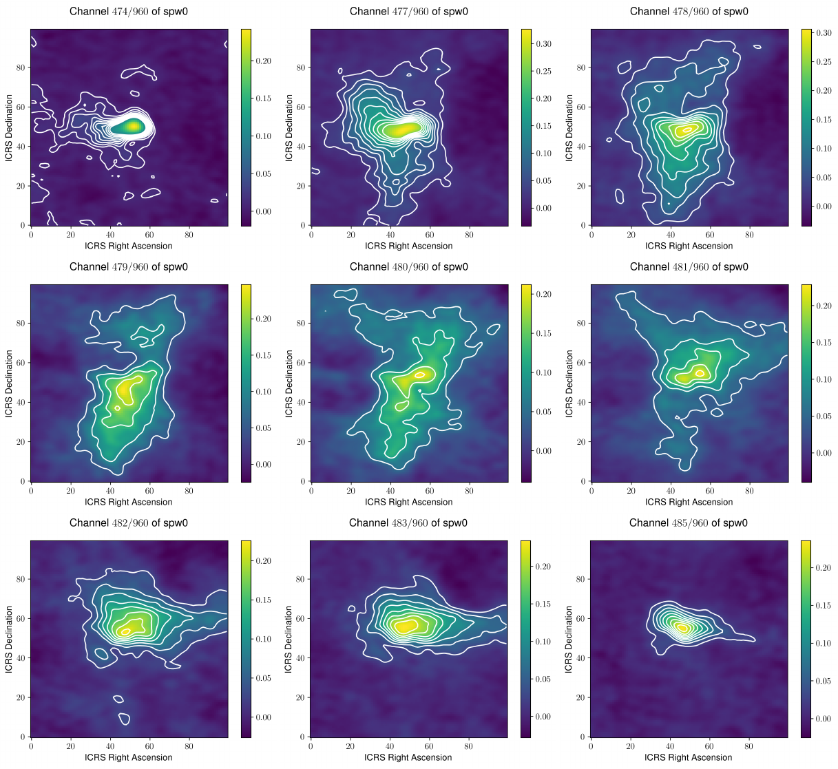

Figure 11 Contour plot of spectral window 0

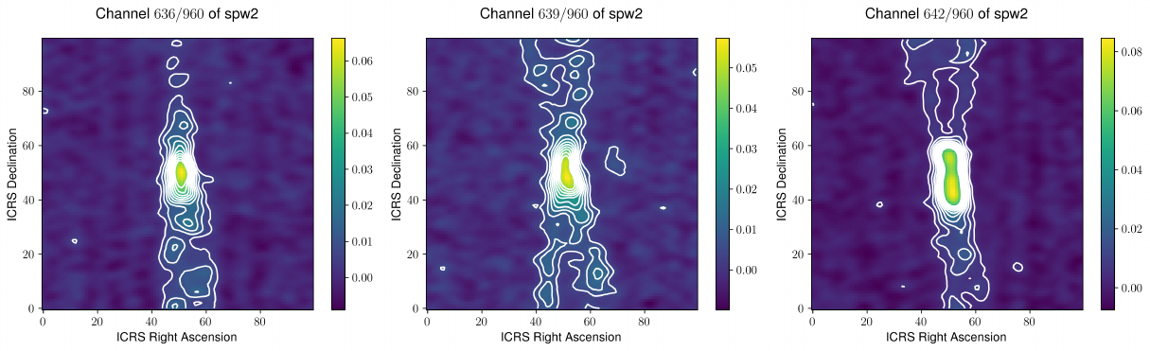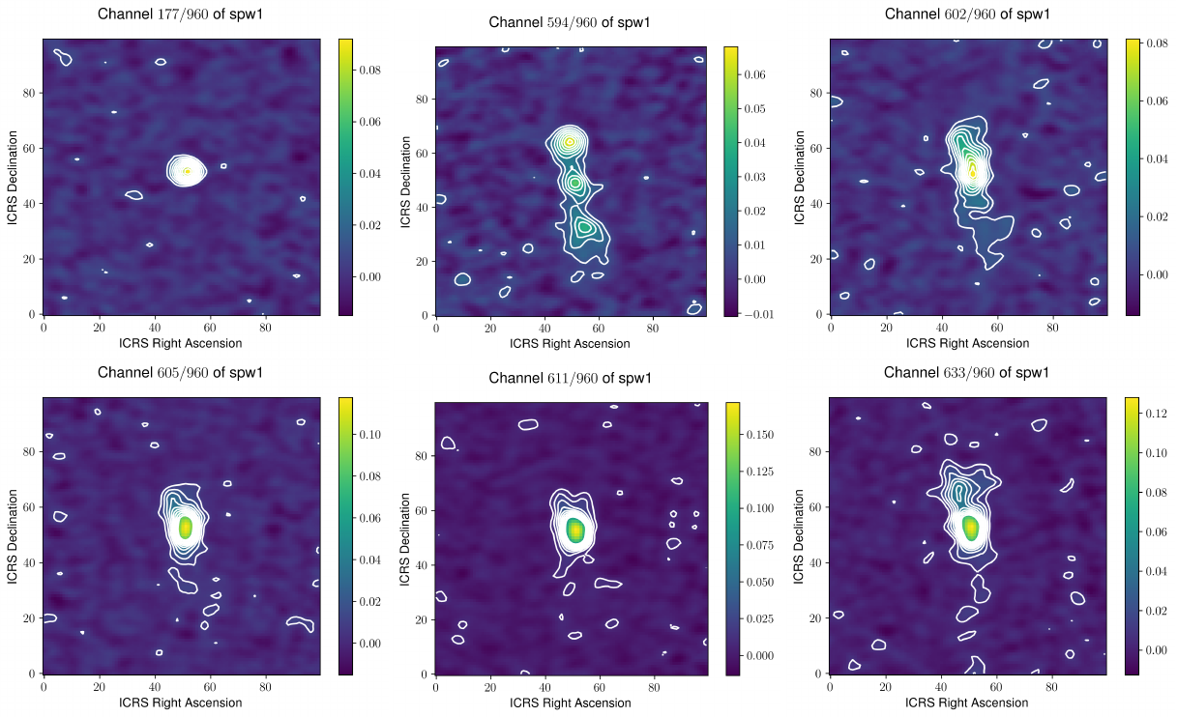

Figure 13 Contour plot of spectral window 2

Figure 12 Contour plot of spectral window 1

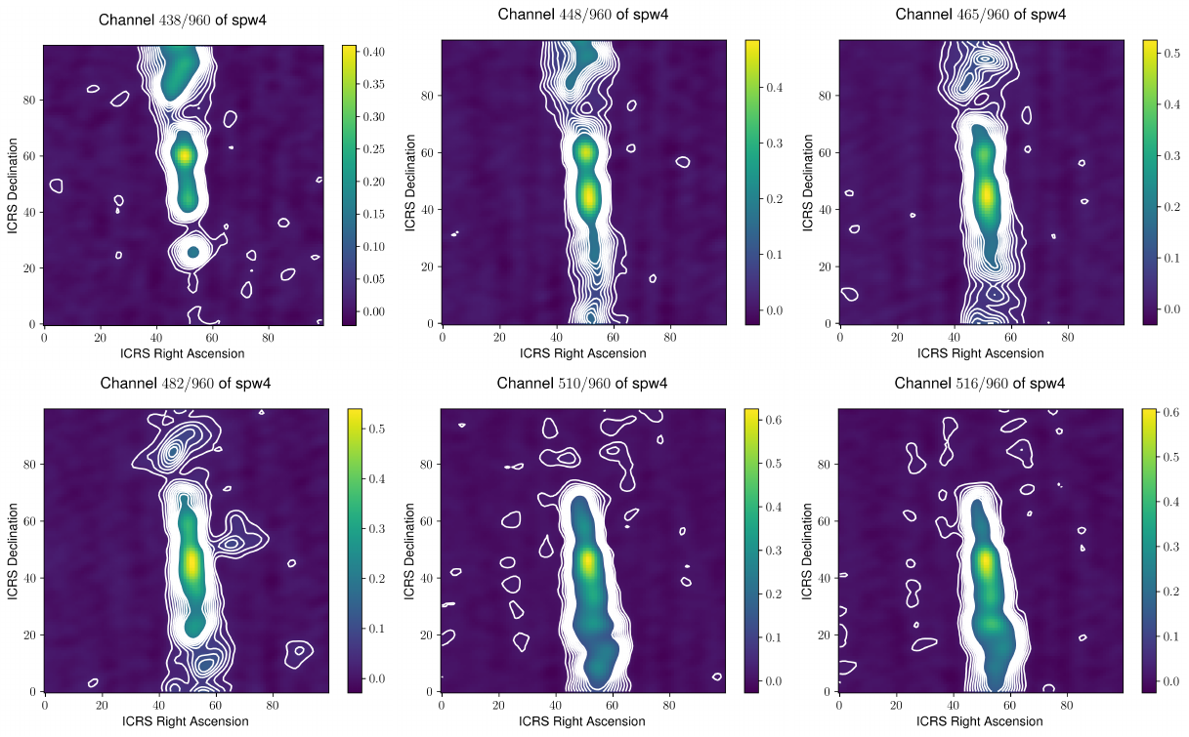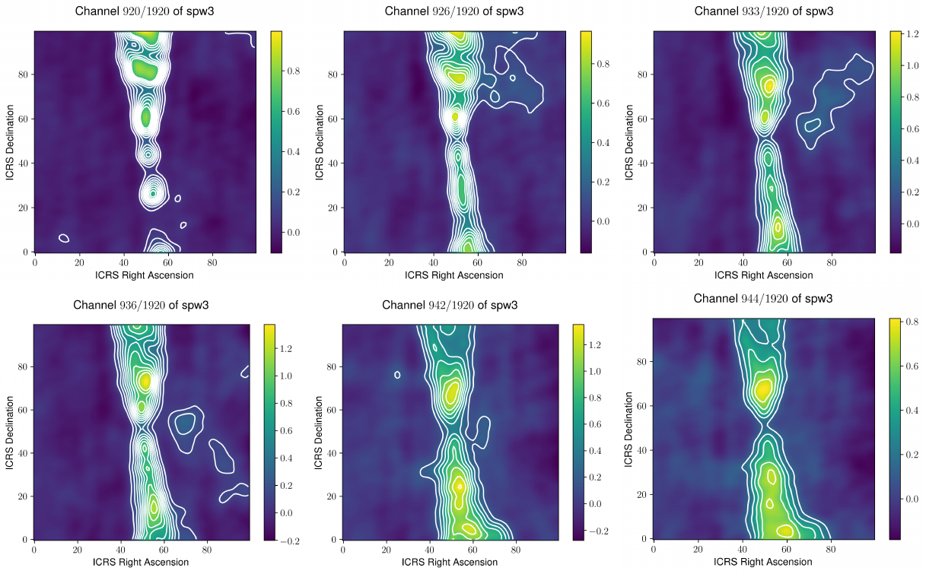

Figure 16 Contour plot of spectral window 4

Figure 14 Contour plot of spectral window 3

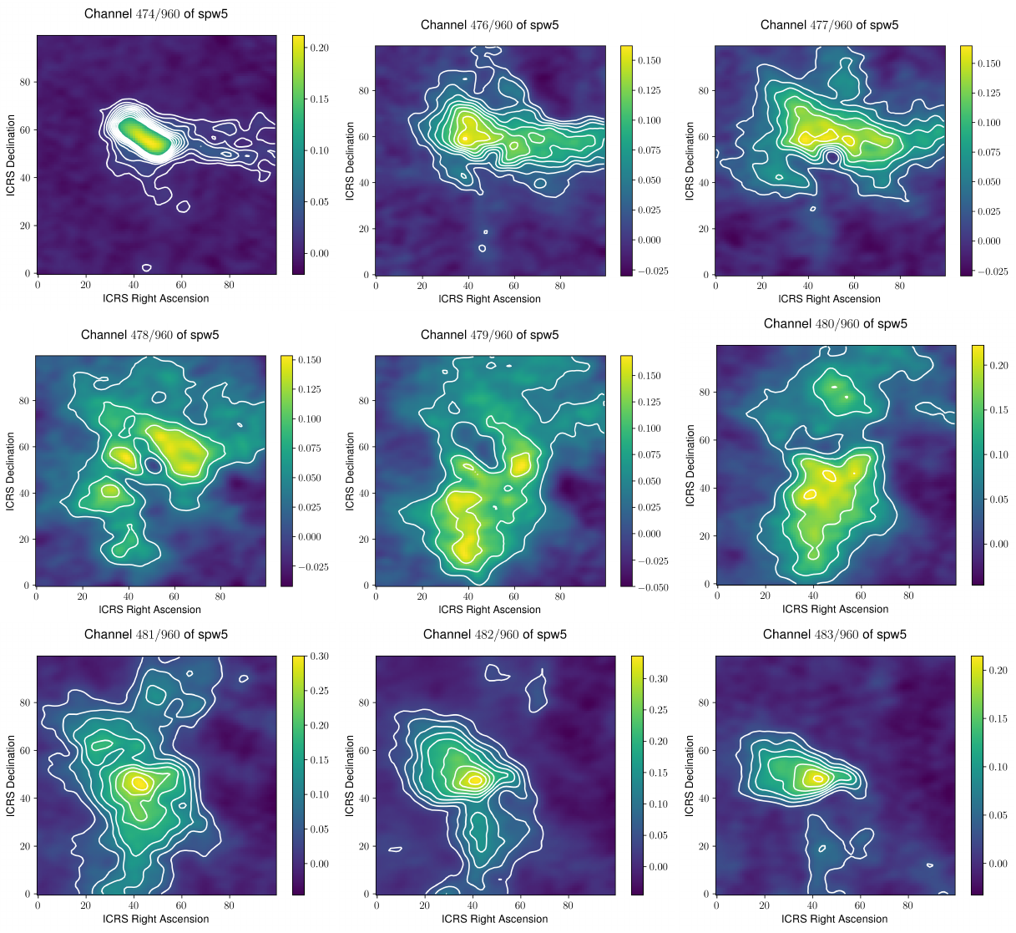

Figure 5 Contour plot of spectral window 5

**References**

1. Surname A, Surname B and Surname C 2015 *Journal Name*
2. Surname A and Surname B 2009 *Journal Name*